NEM 2019 is around the corner
Zagreb, 24th January 2019 - Six years was more than enough for NEM to establish itself as the biggest TV industry event in CEE region. Therefore New Europe Market, the most important 4-day event in Central and Eastern Europe region reveals new dates for the year 2019. The seventh edition of NEM which will, as in previous years, gather professionals and leading experts of media industry from the region and the world, will be held from 10th to 13th of June in beautiful environment of the city of Dubrovnik.
Through theme panels on NEM 2019 we will be introduced to the newest trends in TV industry and develop new ideas and business opportunities, all in the perfect sea setting of Dubrovnik. This year NEM again organizes well known parties which, with fun and some drinks, will not lack in networking. What will be this year's theme and what big names of the industry will attend this NEM, you will find out soon.

NEM 2018 passed with flying colors
Until then, it is worth to mention that more than 800 esteemed participants attended last year's NEM. Of 180 companies which were in Dubrovnik and also supported NEM, we will mention Deutsche Telekom, Comcast, Irdeto, Global Agency, Eutelsat, Keshet International, Lionsgate and many other partners. On the intriguing and interesting panel discussions about the newest accomplishments and the future of media, there were more than 50 panelists.

“We have been keen supporters and sponsors of the event since its inception and are happy to see it grow in recent years”, Katherine Behrends, Managing Director of NBC Universal for Central and Eastern Europe

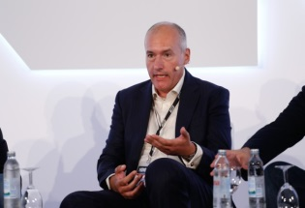

„We know from speaking to our clients that NEM has become a key show for operators in the region, offering unrivalled networking opportunities by bringing content owners and infrastructure players together... all in a breath-taking setting“, said Guy Bisson Reasearch Director, Ampere Analysis.

NEM in numbers
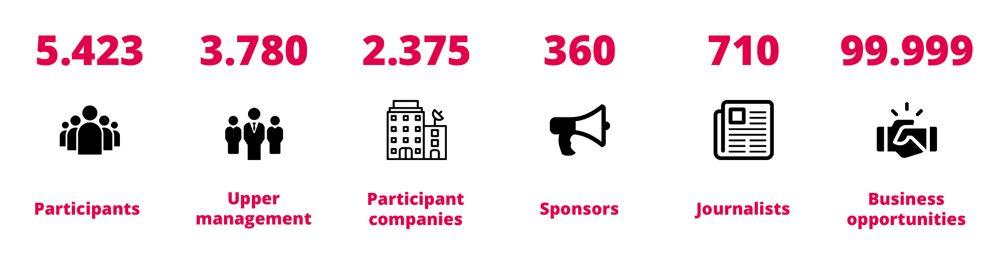

First minute arrangements for NEM 2019
Preparations for NEM 2019 are in full swing and if you want to be a part of the fastest growing TV industry event in CEE region, NEM is currently offering the most affordable arrangements with First minute prices which will be available till 18th of March 2019.

